**Battle for Neighbourhoods**

**Capstone Project - Final Project**

**Background**

The emergence of location services is serving a multitude of uses today. With the current situation of Covid 19, many companies are analyzing the possible problems that they may have due to the possible need or request to telework on the part of their workers. New technologies are influencing a wide variety of decisions to be made by companies when making new decisions at a strategic level. To remain competitive, companies have embraced the use of location data to identify consumer patterns, tastes and trends. Location data is available on various social media platforms, including Google maps, Facebook log data, location reviews on sites like TripAdvisor and Booking, Foursquare, among other providers of location data. A company that wants to relocate its offices in the current situation to ensure that workers telecommute the minimum, has hired a company specialized in data science, with the aim of implanting the offices in an area that improves both the experience of its customers and their loyalty, as well as promoting the majority of workers to attend the office.

**Problem**

The new location of the offices must be in a sufficiently central point of the city of Barcelona, to ensure the existence of all types of transport and facilitate access, and it must have nearby some restaurants to ensure that employees can go out to the street to lunch without wasting a lot of time getting there and back.

**Applying data science to solve the problem**

To solve existing problems, it is necessary to collect location data from Foursquare and apply data science tools and techniques. The data collected will include comparing two locations to determine the best location to recommend the location of the new offices. The two locations under consideration are Barcelona's Plaza Urquinaona and the Sagrada Familia area. The client has requested that offices be proposed where the average distance to the different restaurants in the area is less than 1,400 meters and with a nearby restaurant with good recommendations. We examined these two locations to find the best restaurant and recommend the area that best meets your expectations.

**Methodology**

The customer requirements included some of shopping places and beeing sufficiently central point of the city of Barcelona. The most important requirement was good restaurant. The data was accessed through FourSquare API interface. The data was then visualized using folium package to see the number of restaurants near Plaza Urquinaona and Sagrada Familia.The data extracted from the FourSquare API will be arranged as a dataframe for visualization.

**Results**

**Plaza Urquinaona (Barcelona)**

We found 28 restaurants. The nearest was Piú Restaurant, which was 332 meters from the specific zone. It doesn't have a rating but it has a very good review. The restaurant is located in a place near to the best shopping places of the city.

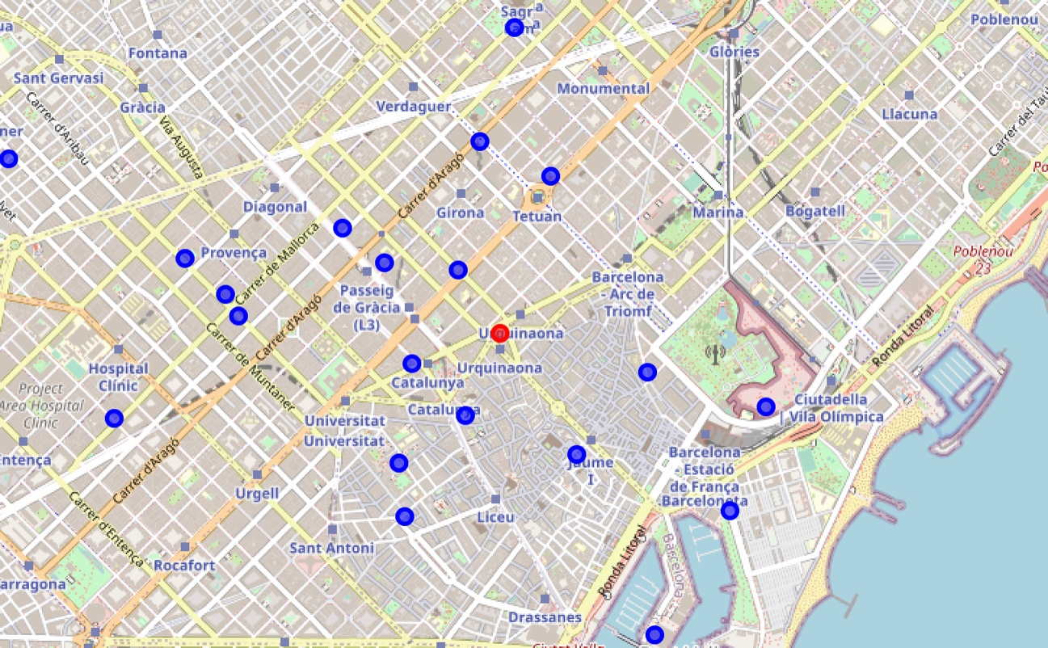

**Sagrada Familia (Barcelona)**

We found 27 restaurants. The nearest was Subway, which was 119 meters from the specific zone but it doesn't have any rating or tip. The next one is Bar Restaurant Sagrada Familia, a bit far, 350 meters. It has a rating of 6.4 and 4 tips. With this rating we didn't analyze the tips. This restaurant is not located ina a place with a lot of shopping places.

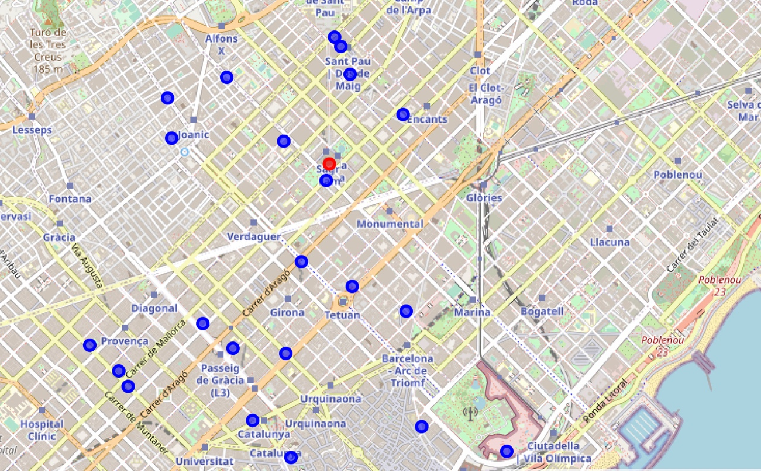

**Discussion**

Based on the client's requirements to find a place with restaurants nearby, that the closest restaurant is well valued, near shopping areas and the analysis presented above, we will recommend Plaza Urquinaona to our client. We hope that the greater concentration of coffee shops in Plaza Urquinaona, as well as the availability of quality coffee shops and the proximity to the best shopping areas in the city, will provide our customers with a good selection and variety.

**Conclusion**

By applying the principles of data science we have been able to compare two locations and visualize the distribution of restaurants in the area. We hope this sets our product apart from the competition and helps us personalize experiences when making strategic business decisions for our customers.